ASSIGNMENT I

****************************************************************************** Course Code: PHY1001 Course Title: ENGINEERING PHYSICS

Due Date: 17 August 2016 Max. Marks 50

Slot : C2 Faculty: Dr. S. Balakrishnan

****************************************************************************** Group: A Reg. No.: 16BCE0789 Name: OM ASHISH MISHRA

Marks Secured for 10______________

******************************************************************************

1. Explain why Compton Effect is not experimentally observed for visible light rays?

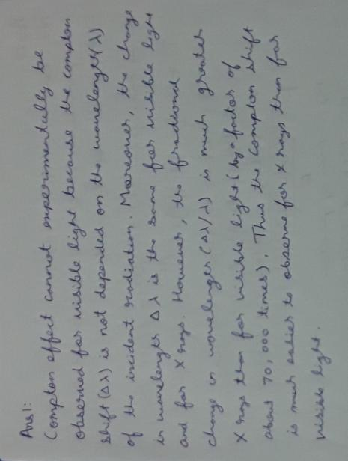

2. X- Rays of wavelength are Compton scattered and the scattered beam is observed at an angle of relative to the incident beam. Determine (a) the wavelength of the scatted X rays (b) the energy of the scattered X ray photons (c) the kinetic energy of the scattered electrons.

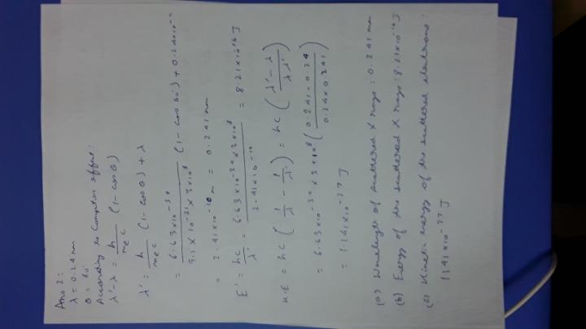

3. Why is the wave nature of matter not more apparent to our daily observation?

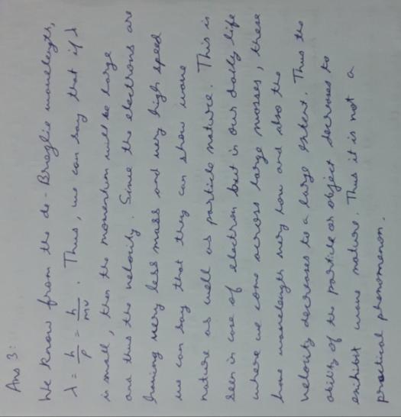

4. Determine the wavelength associated with an electron having kinetic energy equal to . (Hint: Use relativistic equation for total energy and mass)

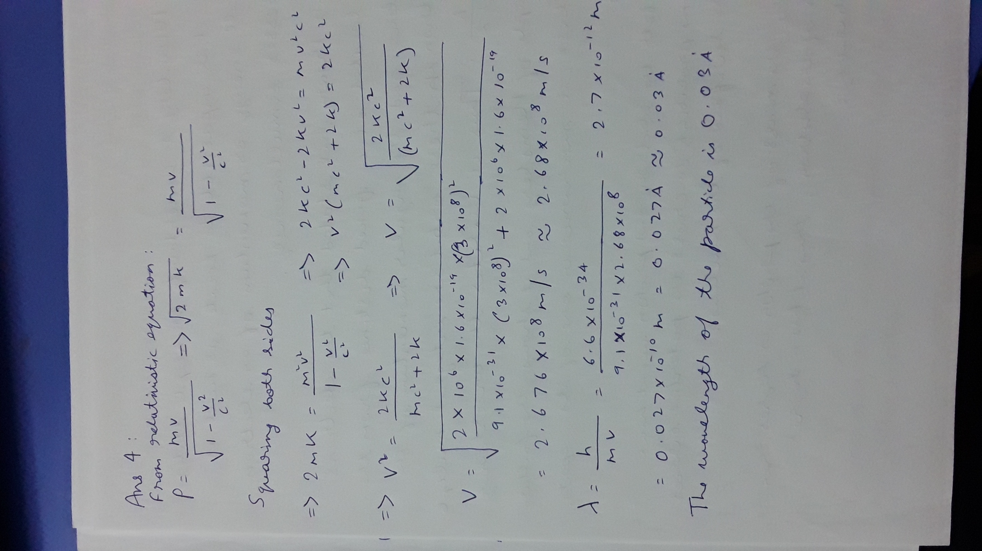

5. Does the concept of Bohr orbit violate the Heisenberg’s uncertainty principle?

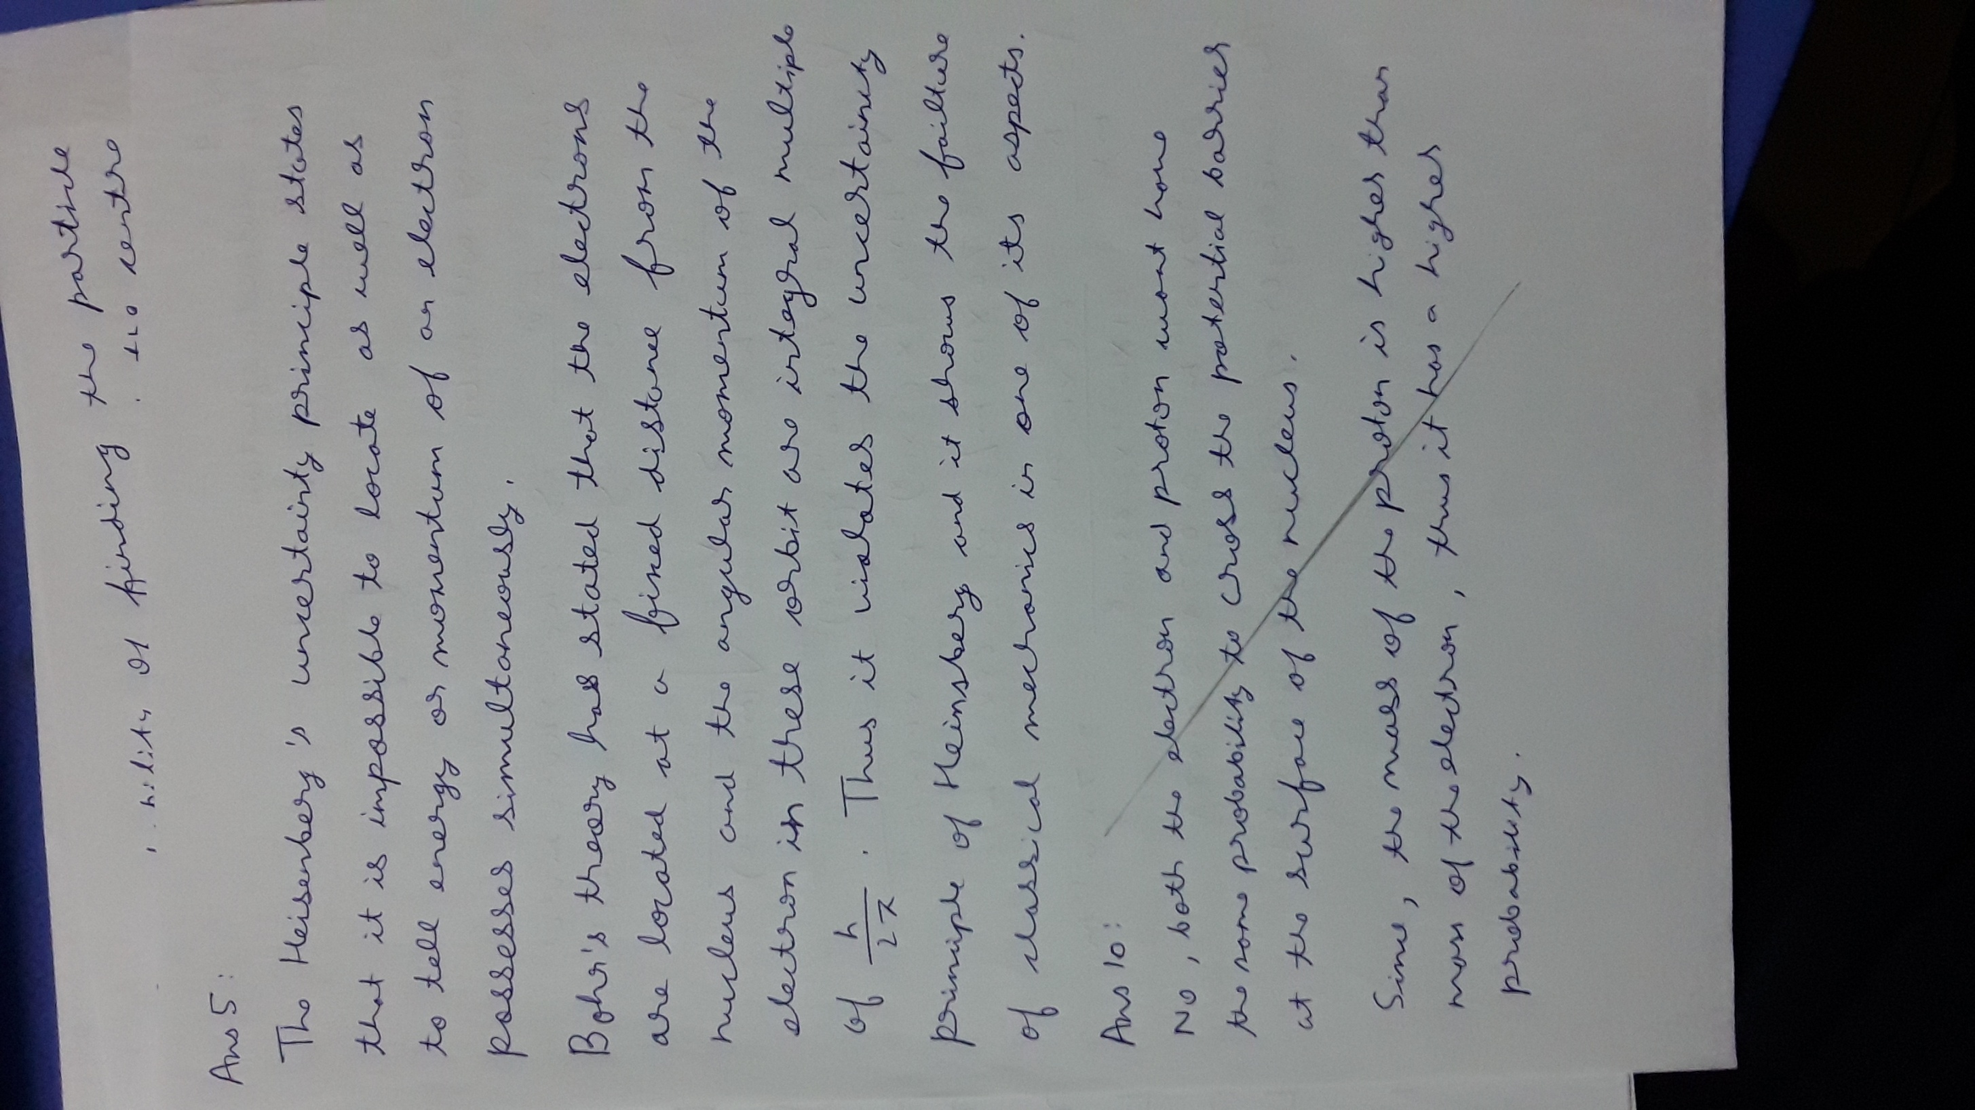6. Compare the following two cases and hence provide proper interpretation. (i) An electron has a speed of 300m/s , accurate to 0.01%. With what fundamental accuracy we can locate the position of the electron? (ii) A bullet of mass 50g, has a speed of 300m/s, accurate to 0.01%. With what fundamental accuracy we can locate the position of bullet?

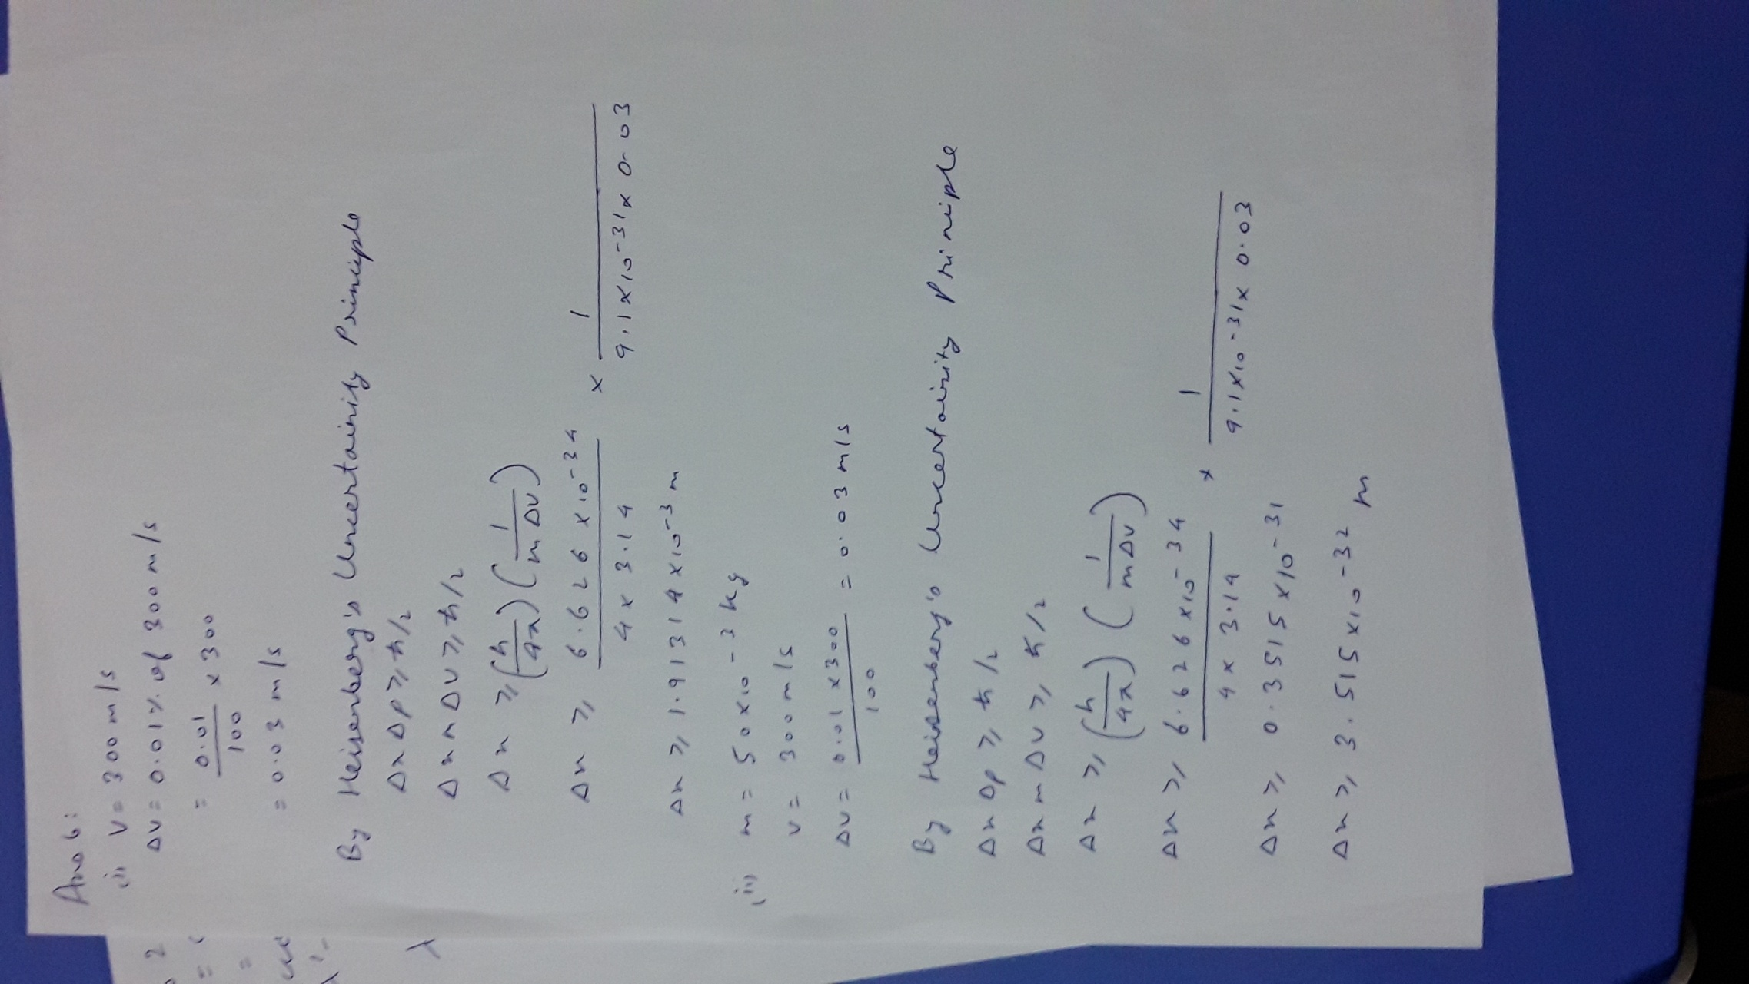

7. Obtain the expression for the energy as well as Eigen function relating to a particle that is confined in a one-dimensional box of finite width. Sketch the wave function and probability density for each level, starting from n=1 to n=4.

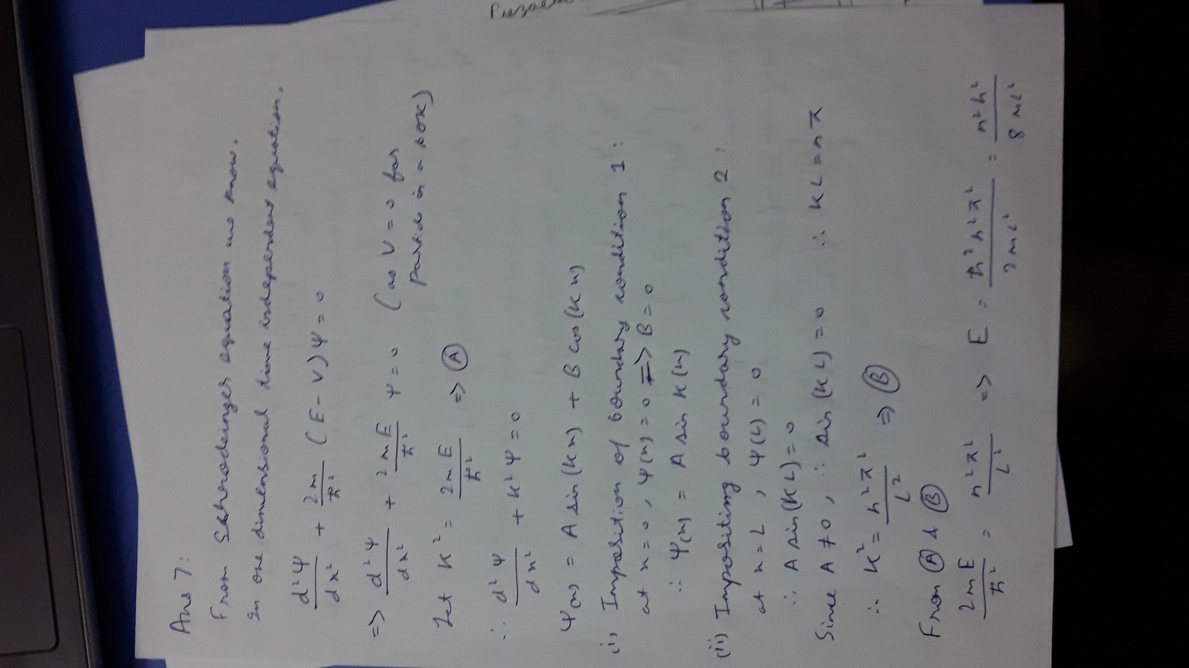

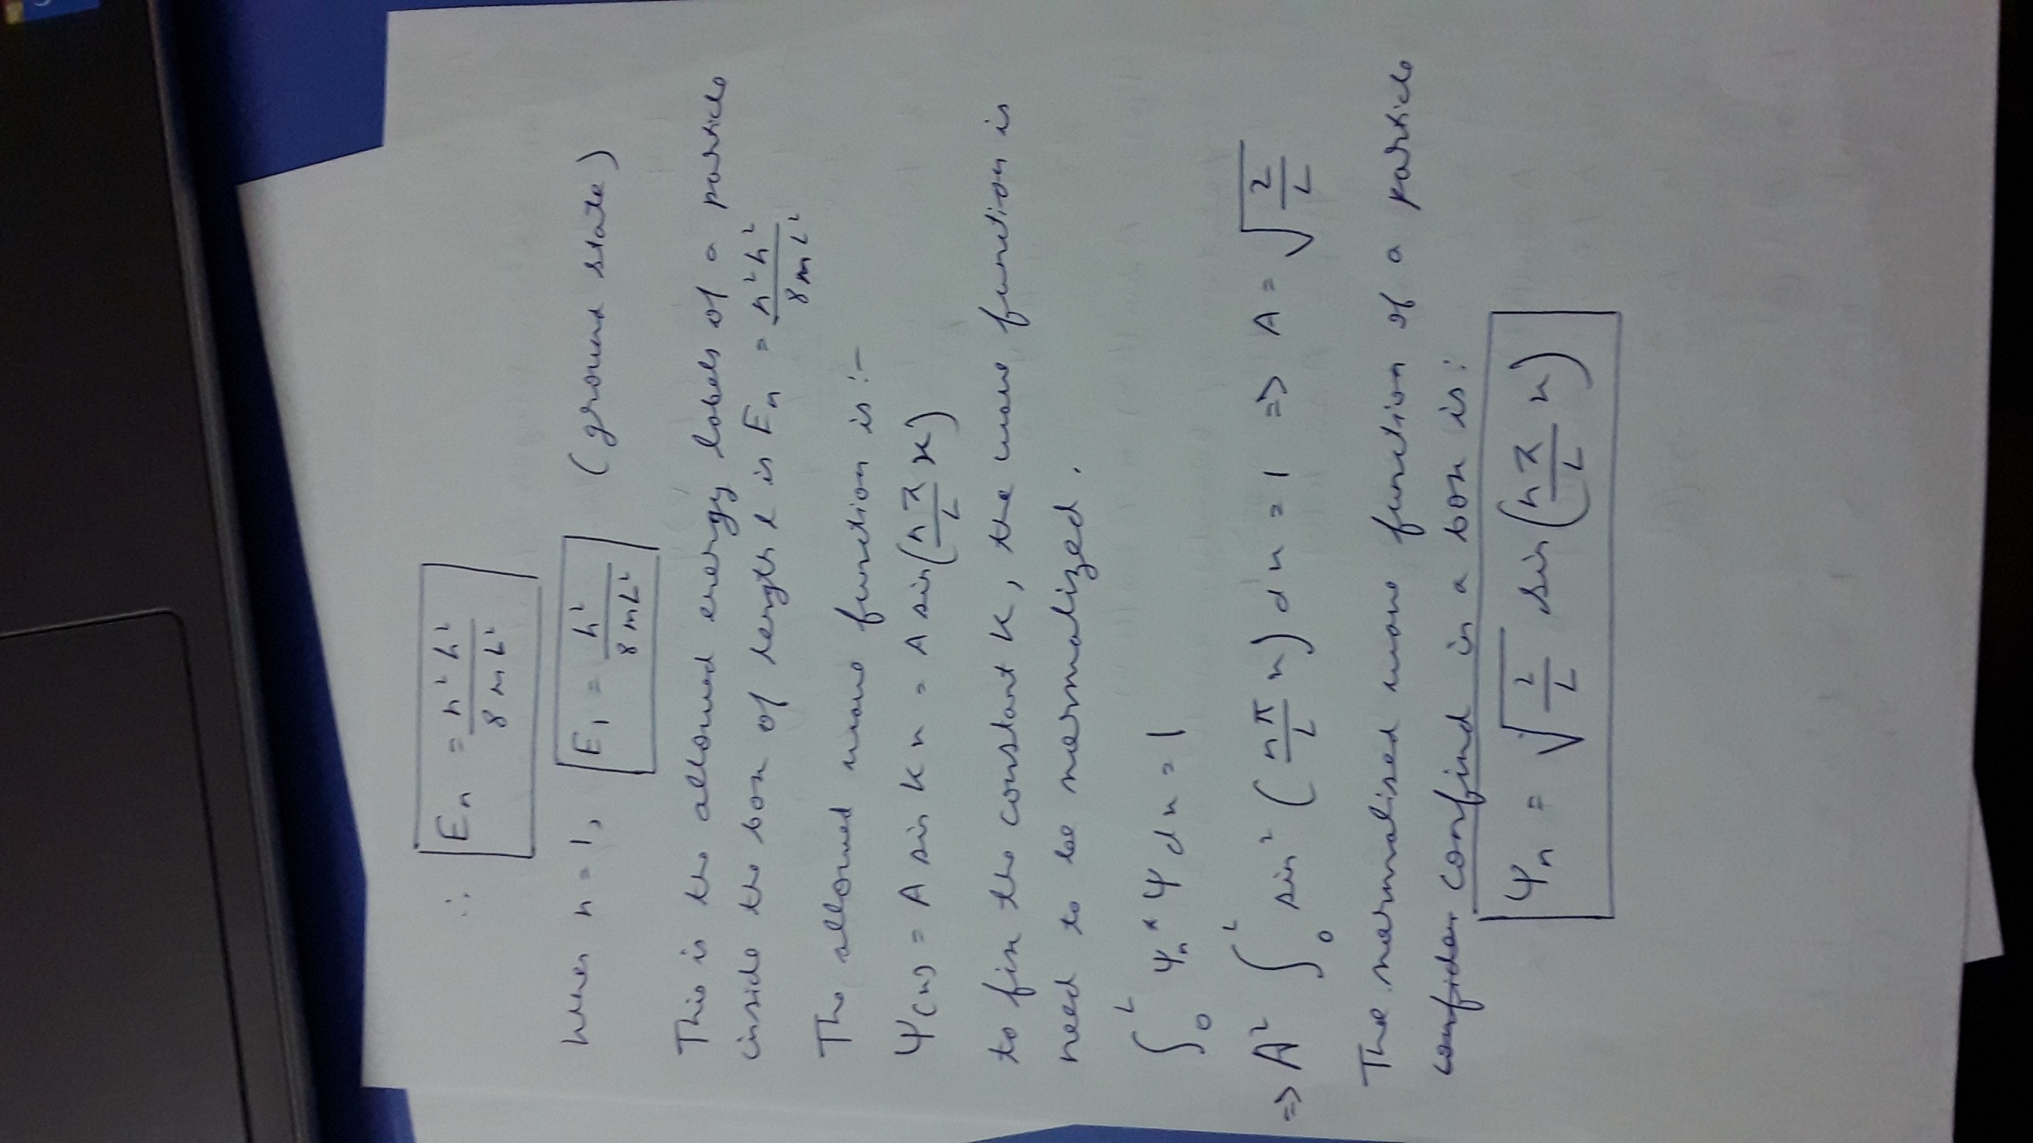

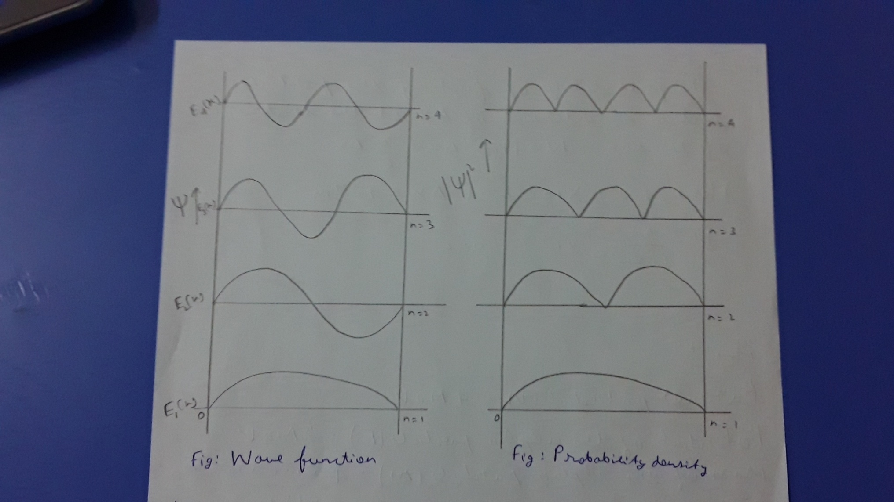

8. A particle is moving in a one dimensional box of width 10armstrong . Calculate the probability of finding the particle within an interval of 1 Armstrong at the centre of the box, when the particle is in state of least energy.

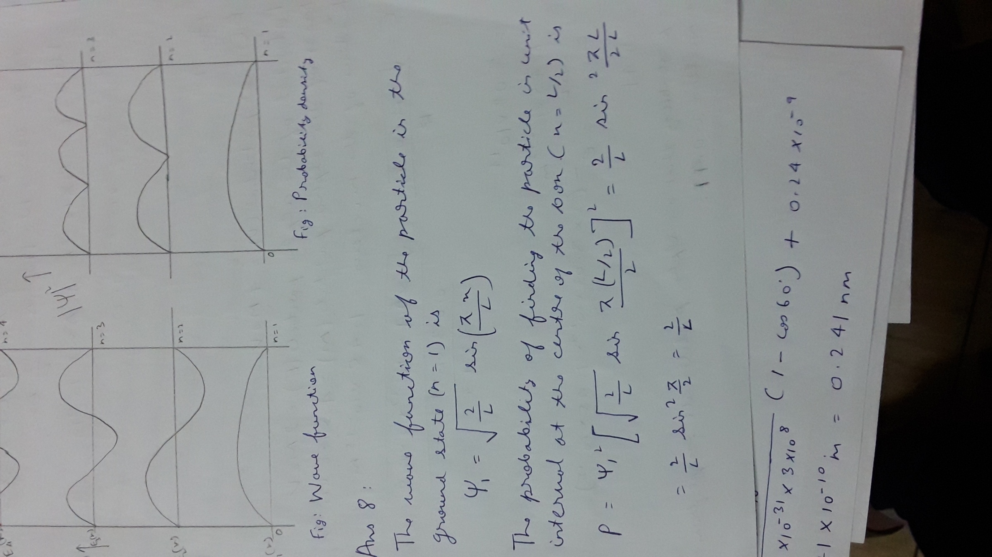

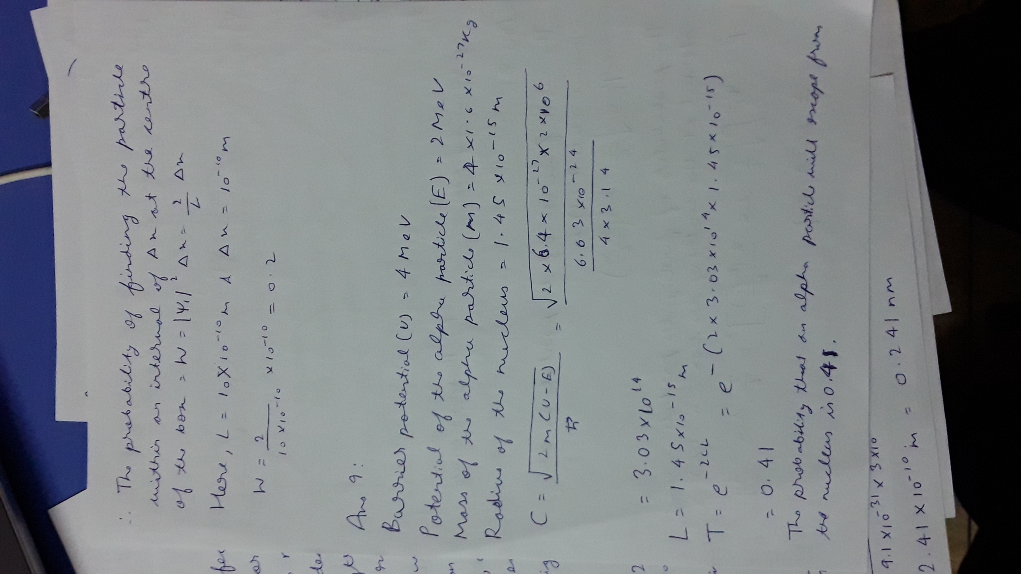

9. An alpha article is trapped in a nucleus whose radius is 1.45x10-15 m . What is the probability that an alpha particle will escape from the nucleus if its energy is 2MeV ?. The potential barrier at the surface of the nucleus is 4MeV.

10. An electron and a proton with the same energy E approach a potential barrier U whose height is greater than E. Do they have same probability of getting through? If not, which has the greater probability?

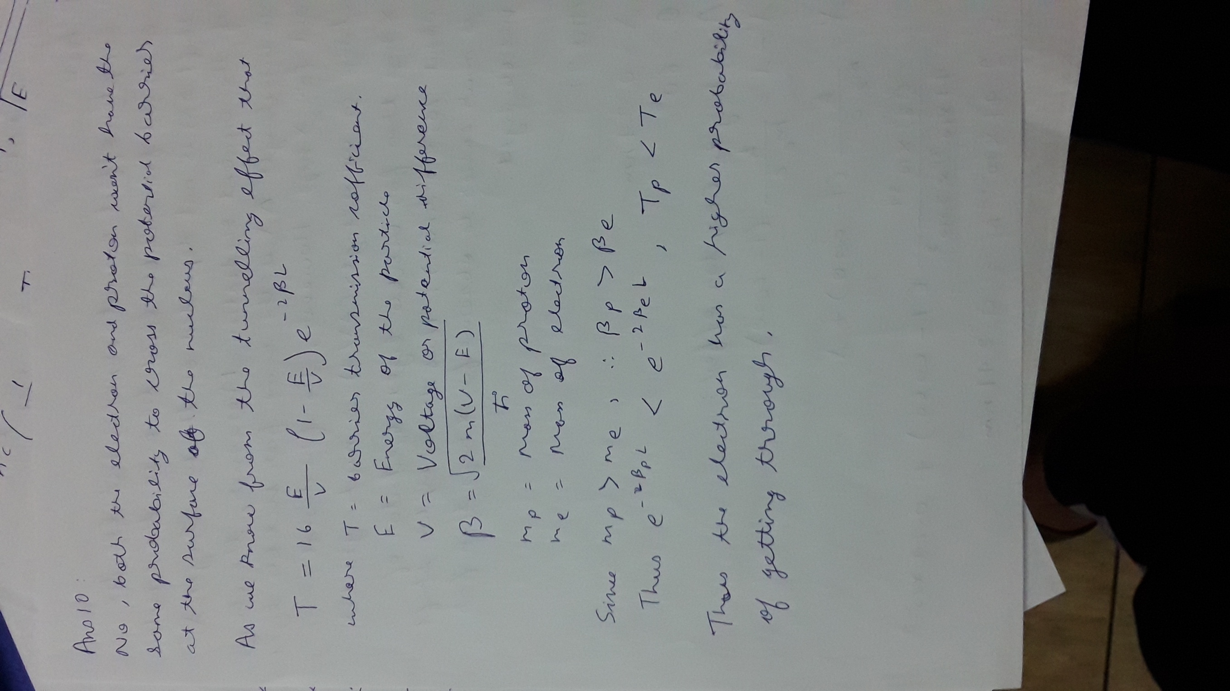

11. With a neat sketch explain the principle and working of STM.

